Assignment 2

Konrad Dittrich, Simon Spång

**Task 1:**

The answer can be found in the class astrobee under the method cartesian_ground_dynamics. It is implemented between the rows 68 to 74. See figure 1.

Figure 1 - A and B matrices

**Task 2:**

See the code in the file task2.py for the use of the methods casadi_c2d and set_discrete_dynamics.

**Task 3:**

The rendezvous constraints are declared as in figure 2.

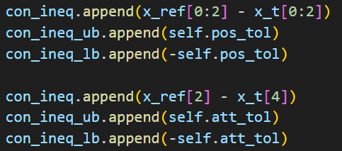

Figure 2 - Rendezvous constraints

Where and

**Task 4:**

The simulation results in the trajectory plots, see figure 3. The goal state is reached after ca. The system behaves as expected and specified.

Figure 3: Trajectory in x and y-direction

**Task 5:**

Since the thruster is broken the Force input is heavily disturbed. This leads to deviations in the control of the position. As a result, the reference state is not reached during simulation time. The root cause for this behavior is that the control is not able to compensate the deviations of the input signal of since the design of the control is not robust enough.

**Task 6:**

To fix the deviation in caused by the noisy -signal we could add a feedback-loop, since this additional policy can reduce the effects of unforeseen disturbances and make the control more robust, see Lecture Chapter 3.1.

**Task 7:**

The model is to be extended by the third dimension by expanding the *cartesiana_3d_dynamics*-function. The Trajectories are plotted in figure 4. A new controller *ctrl_wz* is used which needed 3.73 seconds to obtain a solution. The 2d-simulation took 0.52 seconds. So it’s by factor 7,17 more time consuming to add the third dimension.

Ein Bild, das Text, Diagramm, Reihe, parallel enthält.

Figure 4: Trajectory and control for the 3D-system